WE ARE THE LAWN AGENCY

Do you need TLA?

Do you have an old or worn out lawn?

Does your lawn have excessive moss and thatch?

YES? Then you need US to provide you with a MAKEOVER

What can we do for you?
Brand new lawn | Old lawn removed
100% weed free dressing | Water conserver service
Bespoke feeding service

We will visit you to:
- measure and photograph your lawn
- take a soil sample
- answer any questions.

After the visit we will contact you to let you know the cost of the makeover services we discuss. We will also arrange a date for us to come and start the work and answer any questions you may have.

If at any time you wish to change the services discussed or to ask any further questions you can contact us.

Here are some images for you to look at.

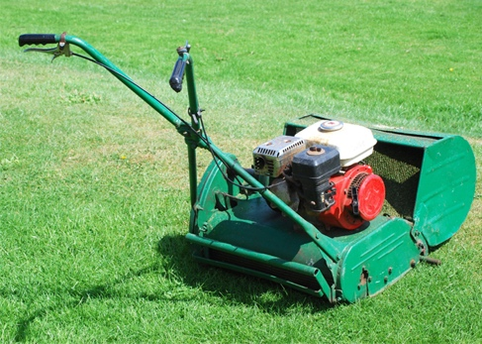

WE LOOK FORWARD TO WORKING ON YOUR GARDEN

Telephone: 07700 900987
Email: medi@tla.net

The Garden
Lawn Terrace
LA6 1GS

